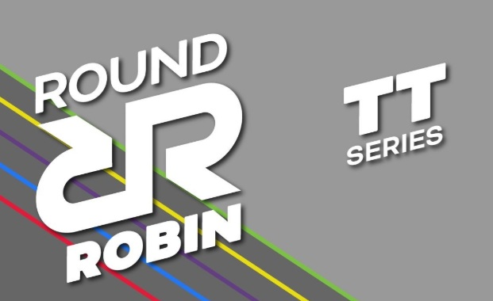
Round Robin TT Series 2026
After a successful debut in 2025, the Round Robin TT Series is back for 2026. With 12 rounds this year and with Kettering Cycling Club joining the party. Local testers are in for a TT treat this summer.
Hinckley Cycle Racing Club, Kettering Cycling Club, Leicester Forest Cycling Club, Ratae Road Club, Rockingham Forest Wheelers and Welland Valley Cycling Club are looking forward to welcoming riders to the 2026 ‘Round Robin’ Summer ten-mile TT series.
The Round Robin series is designed to provide weekly TT opportunities for local cyclists throughout the summer. Each club is running two events and then encouraging their members and others in the wider local cycling community to support the remainder.
These events will use traditional TT days of the week for each Club to fit in with established patterns (participating clubs run 10's on Tuesdays, Wednesdays, Thursday and Saturdays).
The programme is set out below:
Date | Time | Event | Club | Location
June
Tuesday 23 June | 19:00 | Wolvey 10mile TT | Hinckley CRC | Axe & Compass Car Park
Tuesday 30 June | 19:00 | Kibworth 10mile TT | WVCC | Kibworth
July
Thursday 02 July | 19:00 | Lamport 10mile TT | Kettering CC | Lamport
Wednesday 08 July | 19:00 | Caldecott 10mile TT | Rockingham Forest Wheelers | RFW Clubhouse
Saturday 11 July | 11:00 | Gilmorton 10mile TT | Ratae RC | Walton Village Hall
Wednesday 15 July | 19:00 | Caldecott 10mile TT | Rockingham Forest Wheelers | RFW Clubhouse
Tuesday 21 July | 19:00 | Wymeswold 10mile TT | Leicester Forest CC | Wymeswold Memorial Hall
Saturday 25 July | 11:00 | Gilmorton 10mile TT | Ratae RC | Walton Village Hall
Tuesday 28 July | 19:00 | Wolvey 10mile TT | Hinckley CRC | Axe & Compass Car Park
August
Tuesday 04 August | 19:00 | Lubenham 10mile TT | WVCC | Husbands Bosworth
Thursday 13 August | 19:00 | Lamport 9.4 mile TT | Kettering CC | Lamport
Tuesday 18 August | 19:00 | Wymeswold 10mile TT | Leicester Forest CC | Wymeswold Memorial Hall

In addition to these events counting as qualifying rounds in club competitions, there will be Round Robin medals for the overall and women’s competition, and a club competition, competed for by members from the six Round Robin clubs:
- For the overall and women’s competition, the best 6 scores from 9 events will count. In each category the fastest rider scores 60, 2nd scores 55, 3rd 51, and then 48, 46, 44, 42, 40, 39, 38, etc. In the event of a league table evens in a points tie the rider with the lowest overall time will win.
- The Club competition will use the same scoring for the fastest 4 overall riders from each club for each round, plus the fastest female from each club.
Please note that events organised by Rockingham Forest Wheelers need to be entered via the CTT website, and WVCC via Sign Up Genius.
Graphics by Phil Wilkinson

